**FACULTY OF CREATIVE ARTS, TECHNOLOGIES AND SCIENCE**

**Form for Research Ethics Projects (Ethics Form)**

|  |  |
| --- | --- |
| Student Name | Niraj Chudali |
| Student Number | 1915677 |
| Degree Pathway | Bsc. (Hons) Computer Science and Software Engineering |
| Supervisor name | Ajay Kumar Sharma |
| Supervisor Signature |  |
| Title of project | Kishaan |

**SECTION A Proposal**

Please summarise in the research proposal (Screening Form) the ethical issues involved and how they will be addressed.

In any proposal involving human participants please provide information on how:

* informed consent will be obtained
* confidentiality will be observed
* the nature of the research and the means of dissemination of the outcomes will be communicated to participants.

**SECTION B Check List**

Please answer the following questions by circling **YES** or **NO** as appropriate.

|  |  |
| --- | --- |
| Does the study involve vulnerable participants or those unable to give informed consent (e.g. children, people with learning disabilities, your own students)? | **YES** |
| **NO** |
| Will the study require permission of a gatekeeper for access to participants (e.g. schools, self-help groups, residential homes)? | **YES** |
| **NO** |
| Will it be necessary for participants to be involved without consent (e.g. covert observation in non-public places)? | **YES** |
| **NO** |
| Will the study involve sensitive topics (e.g. obtaining information about sexual activity, substance abuse)? | **YES** |
| **NO** |
| Will blood, tissue samples or any other substances be taken from participants? | **YES** |
| **NO** |
| Will the research involve intrusive interventions (e.g. the administration of drugs, hypnosis, physical exercise)? | **YES** |
| **NO** |
| Will financial or other inducements be offered to participants (except reasonable expenses or small tokens of appreciation)? | **YES** |
| **NO** |
| Will the research investigate any aspect of illegal activity (e.g. drugs, crime, underage alcohol consumption or sexual activity)? | **YES** |
| **NO** |
| Will participants be stressed beyond what is considered normal for them? | **YES** |
| **NO** |
| Will the study involve participants from the NHS (patients or staff) or will data be obtained from NHS premises? | **YES** |
| **NO** |

*If the answer to any of the questions above is “Yes”, or if there are any other significant ethical issues, then further ethical consideration is required. Please document carefully how these issues will be addressed.*

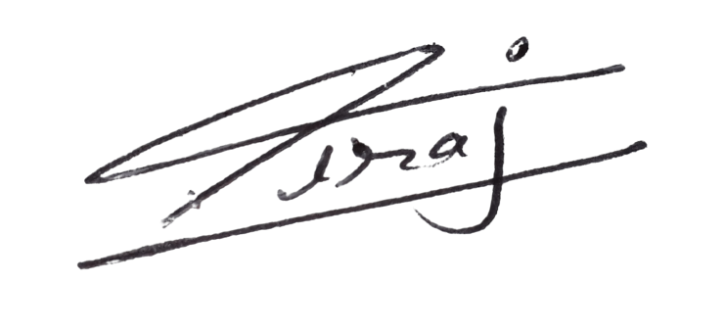

Signed (student):

Date: 2nd Nov, 2021

Countersigned (Supervisor):

Date: